ADAS Traffic Sign Detection & Classification

Overview:
Real-world Advanced Driver Assistance Systems (ADAS) and autonomous vehicles, traffic sign recognition. In this project, you will build this complete two-stage ADAS pipeline. Using the GTSRB (German Traffic Sign Recognition Benchmark)dataset containing over 50,000 images across 43 traffic sign classes, you will first build a Sign Detection & Cropping module that locates and isolates traffic signs from full road scene images.
Project Deliverables:
- EDA
- Object Detection
- Classification
EDA(Exploratory data analysis) :
- Loading the data
- Understanding the data
- Handling null values
- Handling the duplicates data
- Heatmap for correlation between features
- Plot bar chart for class distribution.
- Identified Classes imbalance
- Displayed sample images
- Observed some images are blur and varying backgrounds
- Differentiate traffic signs like some signs are red and blue. Etc
- Shapes are different like triangular, rectangle, circle

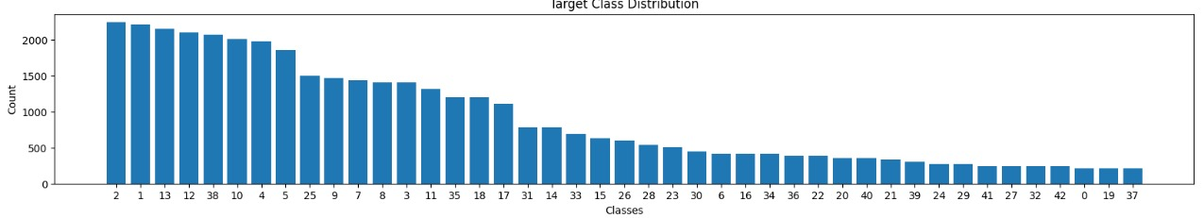
Data Preprocessing:
Images are different sizes so that we have to resize same sizes
We converted (30 ,30) pixels
Using ImageDataGenerator scale the data, splitting the data
Like Training and validation data.
Classmode is categorical and generates one-hot encoded for multiclass classification.

Data Augmentation :
Applied augmentation only training data.
Rotation 15 degrees
Zooming 0.1,shift 0.1
Never applied horizontal and vertical flips

Detection Approach:
Here detection approach is two types
- Manual
- Yolo
First approach :
Using OpenCV color thresholding detection mechanism detection sign and return cropped image
limitations :
- Its captured red sign only
- Blues and yellow signs are not captured that’s why
- We moved another detection approach
Second approach :
- YOLO ("You Only Look Once") is a popular, high-speed real-time object detection framework using convolutional neural networks, allowing computers to identify objects in images and videos within a single pass
- Here we load the pretrained yolo model yolov8n.pt and trained the model using our custom dataset.
- Then our model learns the trends and patterns in the dataset
- Our model can create bounding boxes on images.
- Finally crop the traffic sign from the input image.
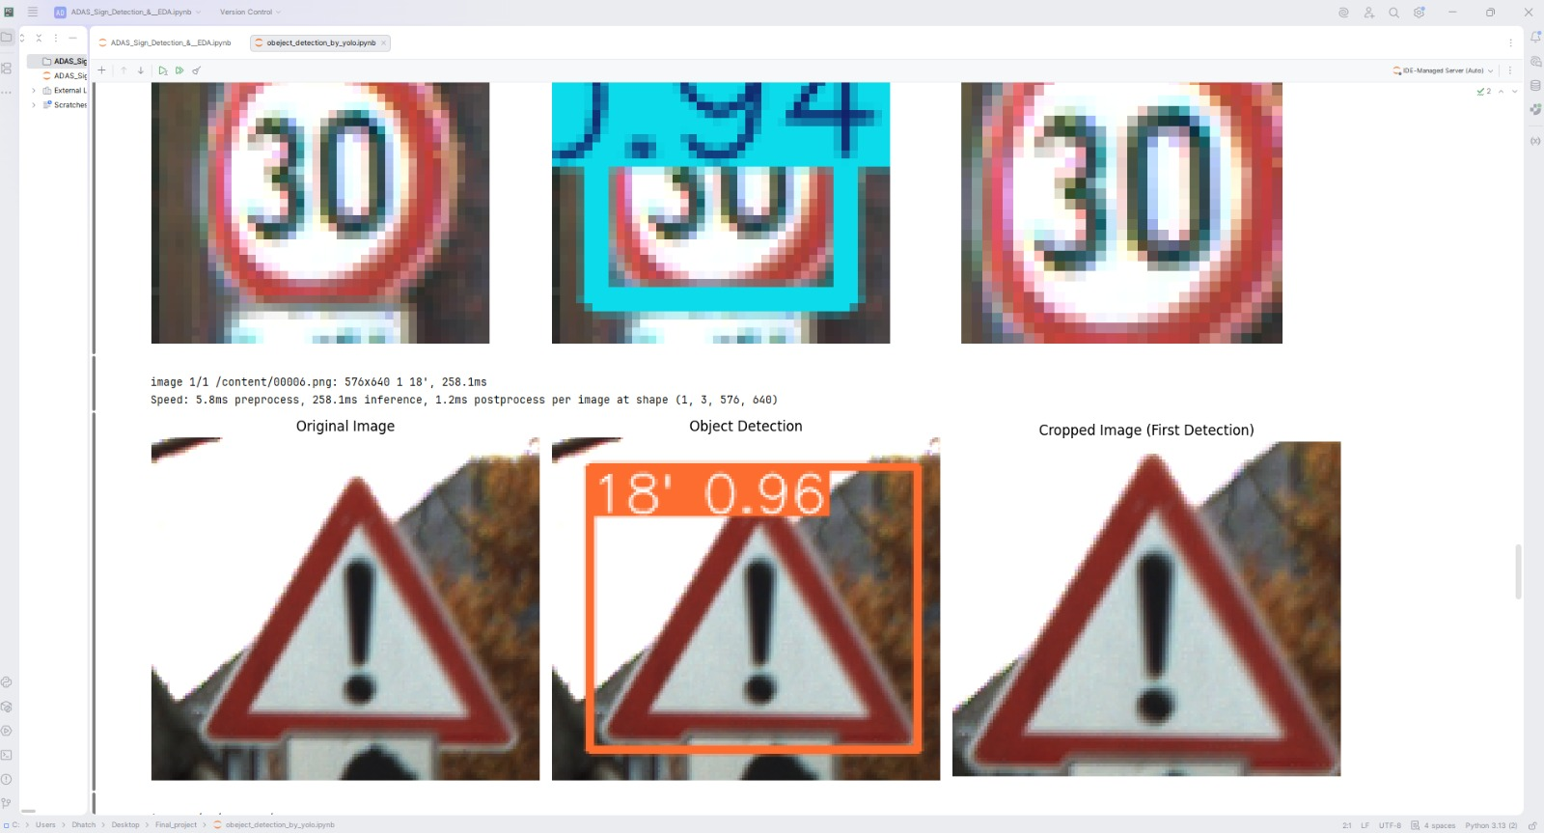

CNN Model Building:
Here we build the CNNs model for multiclass classification.
Three different types of models are building, and we picked one best model from that
Finally, we saved one best model for classification
1> convolution layer
2> pooling layer
3> generalization layer
4> Dense layer
5> Dropout
6> Activation layers(ReLU and SoftMax)
Pretrained models:
- mobilenetv2, loaded the pretrained model and and added the dense layer and final output layer
- Model cannot capture trends in the data
- Model performance is very poor in this dataset
- Then again loaded another type of pretrained model resnet50
- Added dense and final layer for output
- This model is also not performing well
- Very poor performance for this problem.
Data frame:
'Models' : ['CNNs_model1', 'CNNs_model2','CNNs_model2', 'MobileNETV2', 'ResNet50'],
'Layers' : [10, 10, 13, 4, 4],
'neurons' : [565, 299, 565,565, 565],
'Val_Accuracy' : [0.96, 0.95, 0.95, 0.21, 0.266],
'Train_Accuracy' : [0.98, 0.98, 0.98, 0.37, 0.38],
'Val_Loss' : [0.08, 0.06, 0.05, 2.61, 2.62],
'Train_Loss' : [0.17, 0.26, 0.17, 2.08, 2.02],

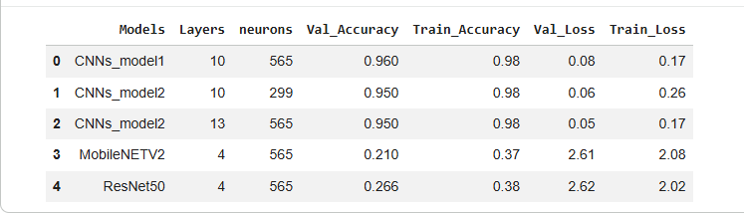

Mode Build:
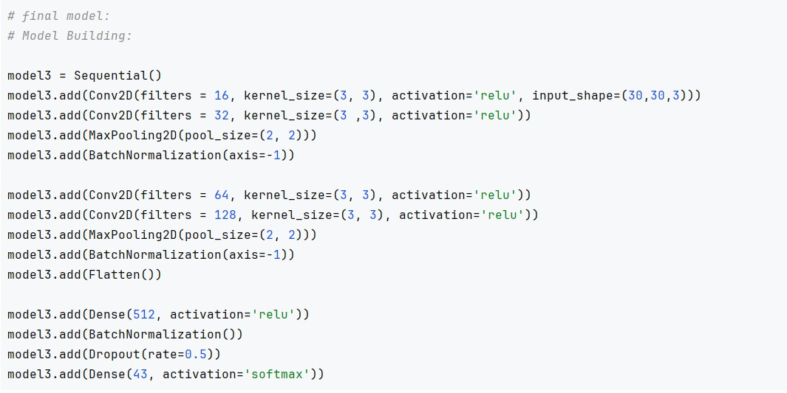
Streamlit application :
Build a Streamlit application for this project. Get the input from the user model is detected the sign and return the crop sign for CNN model
The CNN model is going to perform well for identifying the sign.

Model Validations:
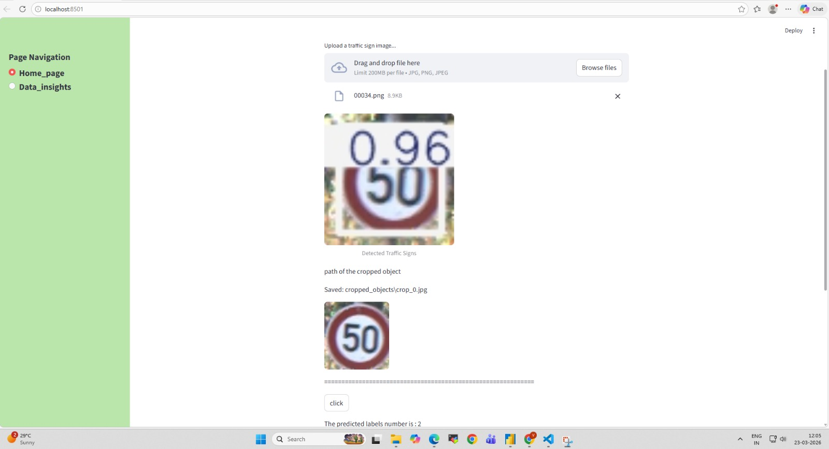
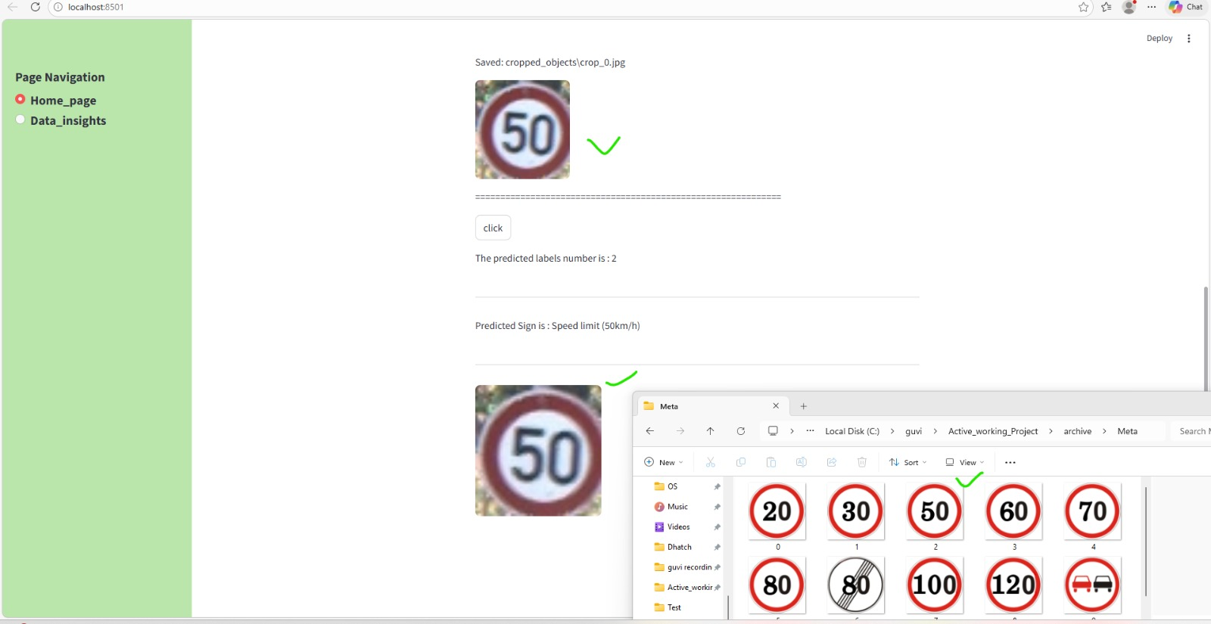

Accuracy and Loss plot.
